SP3  
PROPOSAL

SP3 Team 5

**GAME DESC**

3D Horror Adventure. Story incorporated [linear, transitions between each level]. Main Hub for “Lobby”/Linking of levels >> Main Hub will have a shop as well where player can trade materials for items(ammunitions/weapons/boosts etc). Ghosts will appear in the story (triggered), ghosts will have jump scares and some patrolling and movement. Capturing ghosts will give player ectoplasm which can be traded at shop in main hub. Game will have mini bosses per level excluding last level which will have the final boss. Combat>>hitting different parts of the enemy will apply different damage. Breakable objects will be in the game which would lead to hidden rooms etc.

**MAIN FEATURES**

Terrain Collision (Barycentric Collision) - GUANG ZHE

AABB tree Collision - GUANG ZHE  
Shooting ghost (laser[rope style], grenade, gun[bullet]) - JASON  
Capturing ghost (Vaccum or laser or vaccum laser?) - JASON  
Simple AI [static] - SRI SHAM  
Sound (BGM, SFX, 3D Sound) (IRRKLANG) - JIAHAO  
GUI & INVENTORY - JIAHAO  
Minimap - SRI SHAM  
Night Vision - SRI SHAM

**SIDE FEATURES**

Main Menu - JIAHAO

Options screen - JASON

Pause screen - SRI SHAM

Inventory interface - JIAHAO

Shadows (soft shadow [poisson 16-sample]) - GUANG ZHE

Third person camera (extra) - SRI SHAM

Reflections - GUANG ZHE  
Different Weapons - JASON  
Church of harambe (Shop) - JIAHAO

Day Night cycle (Different ghost at different time) - SRI SHAM

Cel shading - GUANG ZHE

Rope physics (extra)

FBX loader - Sham & GZ

Save and load game (extra)

Level layout

Skyplane : Day & Night;

Level 1 : Indoor - Jason indoor

Level 2 : Outdoor - Jiahao outdoor

Level 3 : Jungle/Forest - Guang Zhe

Level 4 : Graveyard - Sri Sham

Shop:

Ammo for each weapon

Weapons

Batteries for torchlight

Night vision

Enemies:

3 regular ghost (sprite billboard)

1 final boss (OBJ)

Special Objects in world:

Chest  
Breakable Objects

Sounds:

6 BGMS (1 per level, 1 for Main Hub/Shop, 1 for Main Menu)

Each different SFX ( Capture and hit should have different sound)

Interaction to have SFX (depends on object, basic interactions can have mutual sfx)

**Level 1 Screenshot Example:**

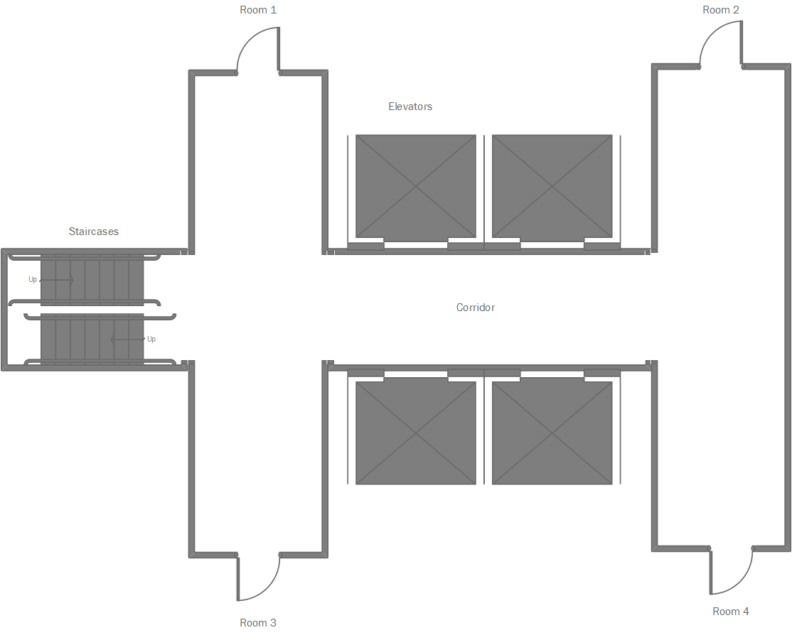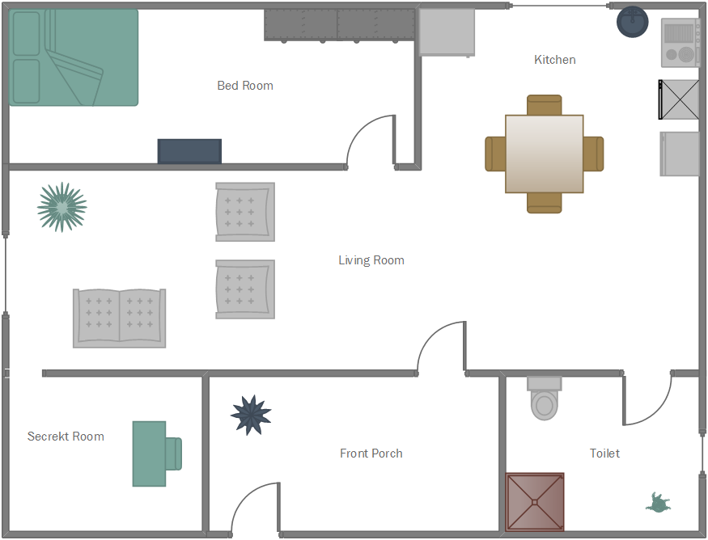

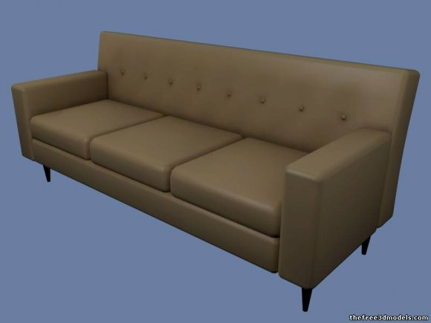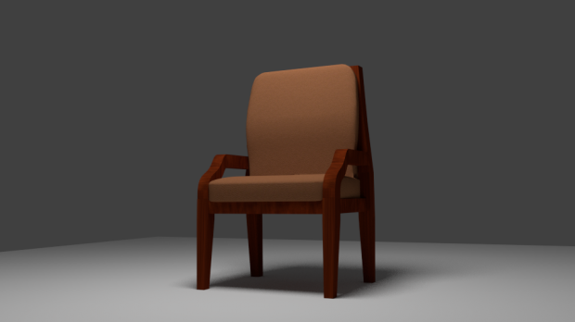

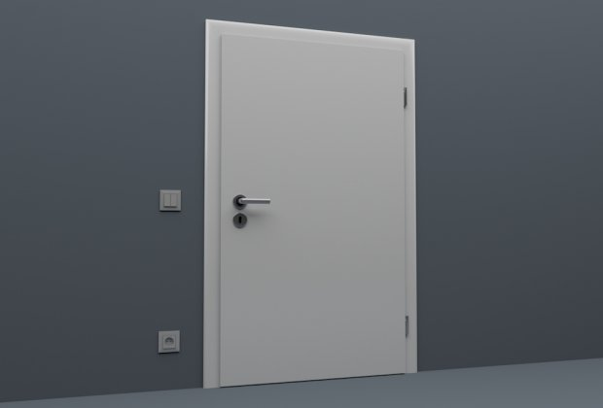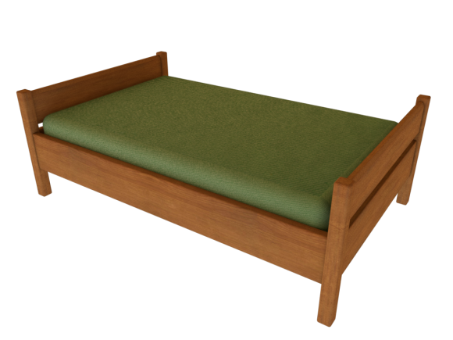

**Menu, pause, game end screen. Level 2 layout.**

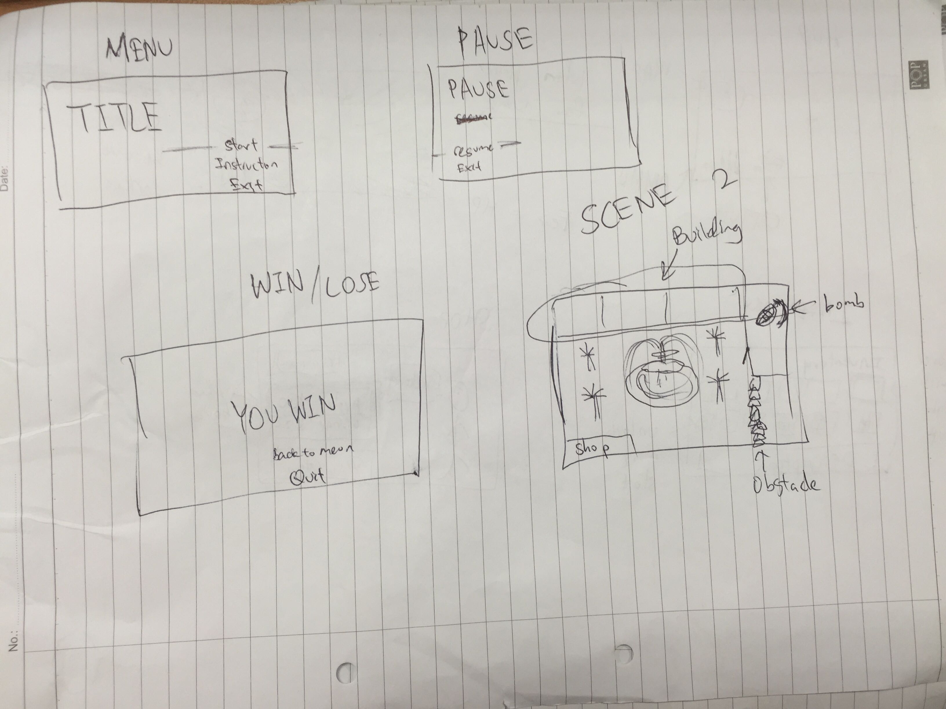

**HUD[Inventory layout and Shop]**

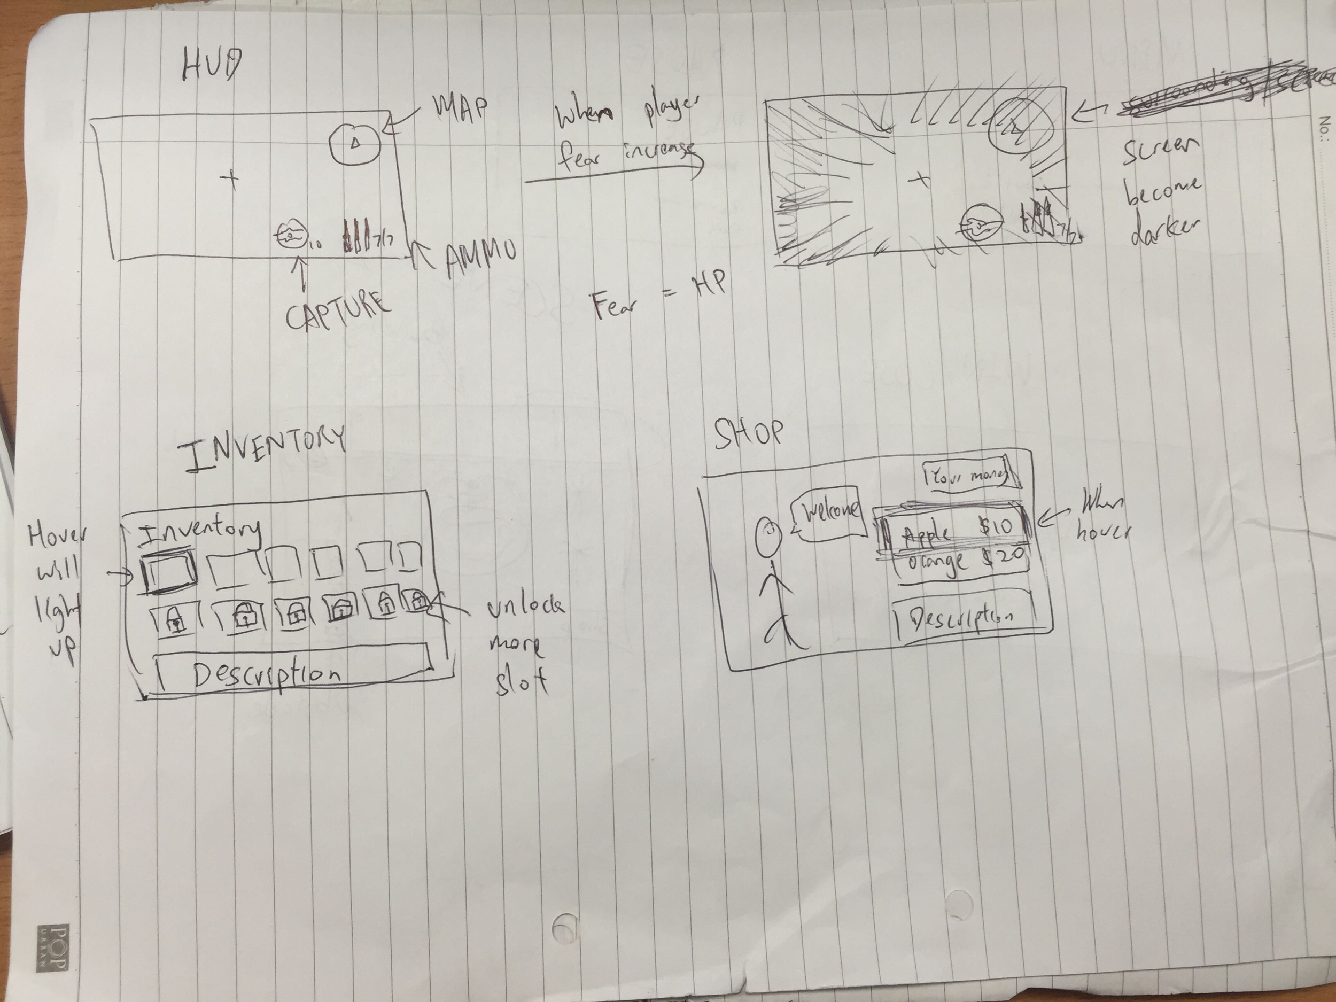

**Level 3 - Jungle/Forest**

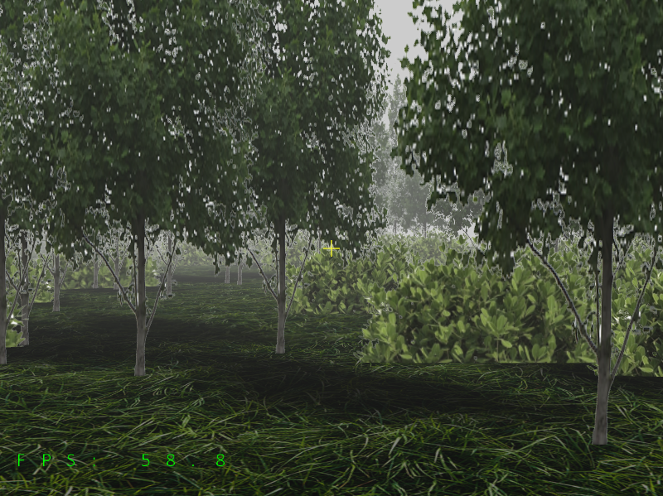

**Level 4 - Graveyard**

